Here is the complete Database Design & System Architecture Document structured specifically for your SIH (Smart India Hackathon) submission.

1. Entity-Relationship (ER) Schema
PostgreSQL / Supabase Relational Model
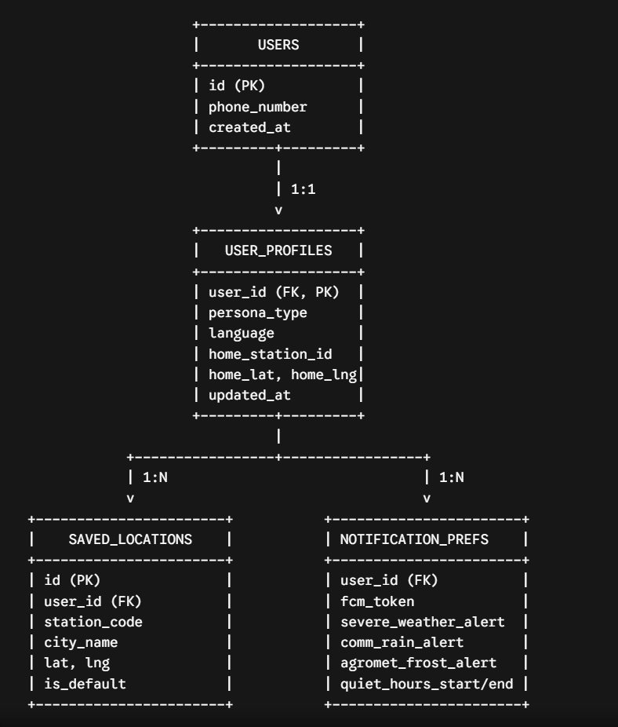

2. Table Definitions (DDL)
SQL
CREATE TYPE persona_enum AS ENUM (
'HEALTH_SENSITIVE', 'FITNESS', 'BEACHGOER',
'TRAVELER', 'FARMER', 'COMMUTER'
);

-- Core Users Table (Syncs with Firebase Auth UID)
CREATE TABLE users (
id VARCHAR(128) PRIMARY KEY, -- Firebase UID
phone_number VARCHAR(15) UNIQUE NOT NULL,
created_at TIMESTAMP WITH TIME ZONE DEFAULT CURRENT_TIMESTAMP
);

-- User Profile & Personalization Preferences
CREATE TABLE user_profiles (
user_id VARCHAR(128) PRIMARY KEY REFERENCES users(id) ON DELETE CASCADE,
persona_type persona_enum NOT NULL DEFAULT 'COMMUTER',
language VARCHAR(5) DEFAULT 'en', -- i18n support ('en', 'hi', 'mr', etc.)
home_station_id VARCHAR(50) NOT NULL,
home_lat DECIMAL(9,6) NOT NULL,
home_lng DECIMAL(9,6) NOT NULL,
updated_at TIMESTAMP WITH TIME ZONE DEFAULT CURRENT_TIMESTAMP
);

-- Saved Locations per User
CREATE TABLE saved_locations (
id UUID PRIMARY KEY DEFAULT gen_random_uuid(),
user_id VARCHAR(128) REFERENCES users(id) ON DELETE CASCADE,
station_code VARCHAR(50) NOT NULL,
city_name VARCHAR(100) NOT NULL,
latitude DECIMAL(9,6) NOT NULL,
longitude DECIMAL(9,6) NOT NULL,
is_default BOOLEAN DEFAULT false,
created_at TIMESTAMP WITH TIME ZONE DEFAULT CURRENT_TIMESTAMP
);

-- Notification Tokens and Settings
CREATE TABLE notification_preferences (
user_id VARCHAR(128) PRIMARY KEY REFERENCES users(id) ON DELETE CASCADE,
fcm_token TEXT NOT NULL,
severe_weather_alert BOOLEAN DEFAULT true,
commute_rain_alert BOOLEAN DEFAULT true,
agromet_frost_alert BOOLEAN DEFAULT false,
quiet_hours_start TIME DEFAULT '22:00:00',
quiet_hours_end TIME DEFAULT '06:00:00',
updated_at TIMESTAMP WITH TIME ZONE DEFAULT CURRENT_TIMESTAMP
);

-- Static Mapping Table for IMD Station Codes
CREATE TABLE imd_stations (
station_code VARCHAR(50) PRIMARY KEY,
station_name VARCHAR(100) NOT NULL,
state VARCHAR(100) NOT NULL,
latitude DECIMAL(9,6),
longitude DECIMAL(9,6),
has_coastal_bulletin BOOLEAN DEFAULT false
);
3. Caching & Static Snapshot Strategy (Redis + Local JSON)
To ensure zero downtime during stage demos (even if public government endpoints fail), the BFF employs a three-tier fallback cache strategy:

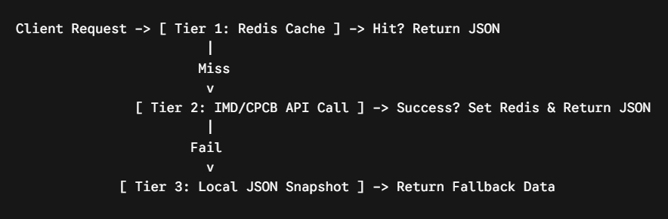Redis Key Architecture
Key Pattern | TTL | Source Endpoint | Description
cache:imd:cityforecast:{station_id} | 1800s (30m) | api.imd.gov.in/api/v1/cityforecast?id={id} | 7-day city weather forecast
cache:imd:nowcast:{district_id} | 900s (15m) | IMD District Nowcast | 3-hour rapid update weather
cache:imd:warnings:{district_id} | 1800s (30m) | IMD District Warnings | Color-coded severe weather warnings
cache:cpcb:aqi:{station_id} | 1800s (30m) | CPCB API (data.gov.in) | AQI and individual pollutant levels
cache:persona:{user_id} | 3600s (1h) | Assembled DB + Redis Data | Calculated persona response JSON
4. BFF Data Integration & Composite Scoring Flow
When a user opens the app, the BFF queries cached external endpoints, computes tailored metrics, and sends a single payload to the UI.

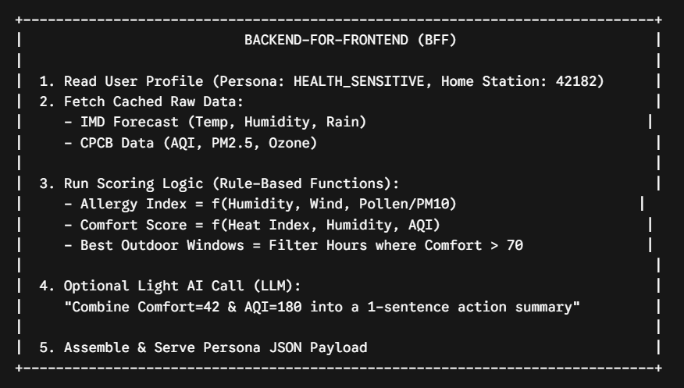Response Schema Served to Frontend (GET /api/v1/personalized-home)
JSON
{
"user_id": "usr_99812",
"persona": "HEALTH_SENSITIVE",
"station_info": {
"station_code": "42182",
"station_name": "New Delhi (SFD)"
},
"natural_language_summary": "AQI is elevated today with high humidity. Limit vigorous outdoor exposure between 12 PM and 4 PM.",
"cards": [
{
"card_type": "ALLERGY_RISK_WIDGET",
"priority": 1,
"data": {
"risk_level": "HIGH",
"score": 78,
"primary_trigger": "PM2.5 & High Humidity",
"raw_aqi": 182
}
},
{
"card_type": "COMFORT_INDEX_CARD",
"priority": 2,
"data": {
"comfort_score": 45,
"category": "Uncomfortable",
"heat_index_c": 38.5,
"humidity_percent": 74
}
},
{
"card_type": "BEST_HOURS_TIMELINE",
"priority": 3,
"data": {
"recommended_window": "06:00 AM - 08:00 AM",
"window_score": 82
}
}
]
}

5. Integration Package Architecture (Pluggable SDK)
To position your project as an upgrade to IMD's existing system rather than a complete replacement, package your core capabilities into an integration SDK:
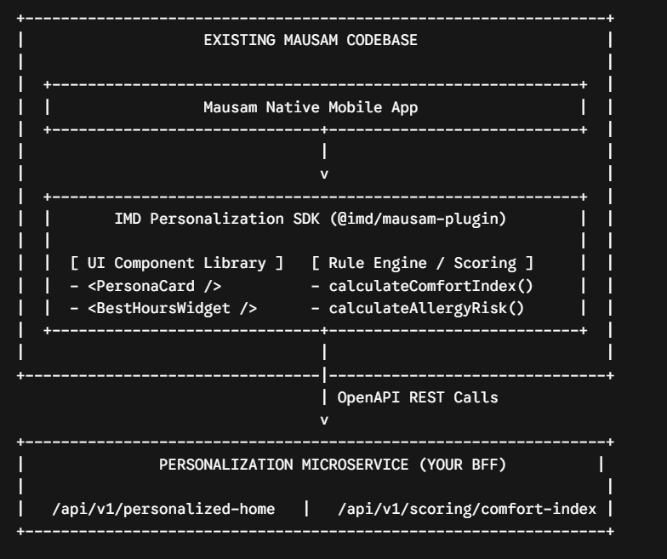
Package Deliverables
- @imd/mausam-plugin (NPM Module): Contains React Native components (<ComfortWidget/>, <PersonaCard/>) that plug directly into existing screens.

- OpenAPI 3.0 Specification (swagger.json): Documents all personalization middleware endpoints for IMD's backend engineering team.

- Fallback Offline Mock Injector: A fallback service built into the SDK that automatically provides static JSON backups if primary server connections time out.

